Part D Coverage Phases

Background

Part D is Medicare prescription drug coverage you get through either:
- A stand-alone Part D plan
- Part of your Medicare Advantage Plan
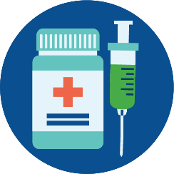

The cost of your Medicare Part D-covered drugs may change throughout the year. If you notice that your drug prices have changed, it may be because you are in a different phase of Part D coverage. There are four different phases—or periods—of Part D coverage.

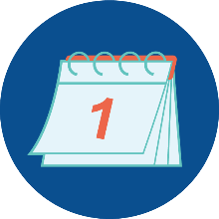
Deductible Period: Until you meet your Part D deductible, you are in the deductible period. During this time, you will pay the full negotiated price for your covered prescription drugs. While deductibles can vary from plan to plan, no plan’s deductible can be higher than $545 in 2024, and some plans have no deductible. You begin each new calendar year in the deductible.

Initial Coverage Period: After you meet your deductible, your plan will help pay for your covered prescription drugs. This is your initial coverage period. Your plan will pay some of the cost, and you will pay a copayment or coinsurance.

Coverage Gap: You enter the coverage gap when your total drug costs—including what you and your plan have paid for your drugs—reaches a certain limit. In 2024, that limit is $5,030. While in the coverage gap, you are responsible for 25% of the cost of your drugs. The coverage gap is also sometimes called the donut hole.

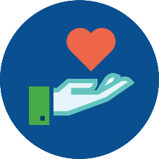
Catastrophic Coverage: In all Part D plans in 2024, you enter catastrophic coverage after you reach $8,000 in out-of-pocket costs for covered drugs. As of 2024, during this period, you owe no coinsurance or co-payments for the cost of your covered drugs for the remainder of the year. This puts a hard cap on your spending during the catastrophic phase of coverage. Before 2024, you paid 5% of the cost.

Part D Coverage Phases

But what counts as an out-of-pocket cost? The out-of-pocket costs that help you reach catastrophic coverage include:
- Your deductible
- What you paid during the initial coverage period
- Almost the full cost of brand-name drugs (including the manufacturer’s discount) purchased during the coverage gap
- Amounts paid by others, like family members, most charities, and other persons on your behalf
- Amounts paid by State Pharmaceutical Assistance Programs (SPAPs), AIDS Drug Assistance Programs, and the Indian Health Service

Costs that do not help you reach catastrophic coverage include monthly premiums, what your plan pays toward drug costs, the cost of non-covered drugs, the cost of covered drugs from pharmacies outside your plan’s network, and the 75% generic discount.

Your plan should keep track of how much money you have spent out of pocket for covered drugs and your progression through coverage periods. This information should appear in your monthly statements.

Beginning in 2025, your out-of-pocket maximum for your Part D-covered prescription drugs will be reduced to $2,000. You will also have the option to pay out-of-pocket Part D costs in monthly payments spread over the year.
2025

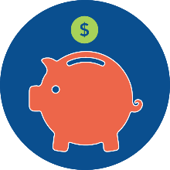
Contact your State Health Insurance Assistance Program (SHIP) to see if you are eligible for programs that can lower your prescription drug costs. Contact information for your SHIP is on the last page of this document.

Pharmacy and Prescription Drug Fraud

There are many types of pharmacy and prescription drug schemes. A few examples include:
- You see charged on your Medicare Summary Notice (MSN) or Explanation of Benefits (EOB) charges for:
  - Drugs that were never picked up, delivered, or even prescribed.
  - Drugs (sometimes controlled drugs such as opioids) that were prescribed by a doctor you have never seen.
  - Drugs beyond the amount you were prescribed.
  - A different prescription drug, often one that costs more, than the one you were prescribed.
  - A drug that is not approved by the U.S. Food and Drug Administration (FDA).
- A pharmacy purposely provided you with less medication than you were prescribed or expired drugs.
- A pharmacy gave you and billed for a costly compounded medication, such as a pain cream, when a lower cost prescription was ordered by your doctor.
- A pharmacy offers you “free” or “discount” drugs without an order from your doctor and then bills Medicare.
- A pharmacy refills a prescription that you no longer need without you knowing it. You don’t pick it up, but the pharmacy still bills Medicare.
- Someone offers to pay you for the use of your Medicare number to bill for prescription drugs or offers you cash or other payment to pick up prescriptions for you.

Read your Medicare statements to check for errors or suspicious charges.

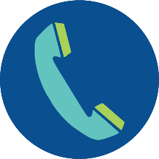
If you have any concerns about your Medicare statements or medications, contact your local Senior Medicare Patrol (SMP). Your SMP can help and report the potential fraud to the correct authorities. Contact information for your local SMP is on the last page of this document.

Part D Coverage Phases

Local SHIP contact information | Local SMP contact information
SHIP toll-free: 1-800-307-4444 | SMP toll-free: 1-800-307-4444
SHIP email: NevadaMAP@adsd.nv.gov | SMP email: NevadaMAP@adsd.nv.gov
SHIP website: https://www.nevadacareconnection.org | SMP website: https://www.nevadacareconnection.org
To find a SHIP in another state:  Call 877-839-2675 (and say “Medicare”  when prompted) or visit www.shiphelp.org | To find an SMP in another state:  Call 877-808-2468 or visit www.smpresource.org
SHIP Technical Assistance Center: 877-839-2675 | www.shiphelp.org | info@shiphelp.org
SMP Resource Center: 877-808-2468 | www.smpresource.org | info@smpresource.org
© 2023 Medicare Rights Center | www.medicareinteractive.org |

The Medicare Rights Center is the author of portions of the content in these materials but is not responsible for any content not authored by the Medicare Rights Center. This document was supported, in part, by grant numbers 90SATC0002 and 90MPRC0002 from the Administration for Community Living (ACL), Department of Health and Human Services, Washington, D.C. 20201. Grantees undertaking projects under government sponsorship are encouraged to express freely their findings and conclusions. Points of view or opinions do not, therefore, necessarily represent official Administration for Community Living policy.

